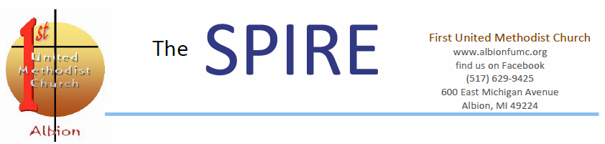
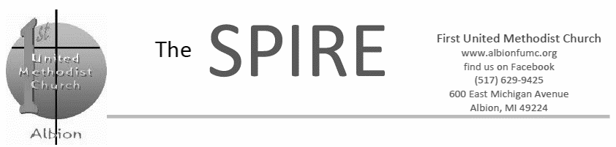
First United Methodist Church
www.albionfirst.org
find us on Facebook
600 East Michigan Avenue
Albion, MI 49224

November 2017
2017 All Saints Remembrance 2
Christian Sympathy
Leadership Listing
Poinsettias
Prayers
Upcoming Dates to Remember

2017 Charge Conference 3
Minutes

Community Health Fair 4
Daylight Savings Time Change
Gourment Nuts and Peanut
Brittle
UMW News and Views

Calendar 5

Follow Jesus; Love Everyone

Fall means a lot of different things to us … changing colors, cooling temperatures, football and apple cider, to name just a few. In the life of the church, this is the time for planning for next year, including budget planning. That’s right, its stewardship campaign season.
For the last couple Sundays, we’ve been talking about our hopes and dreams for this church, about where we feel God calling us to go next in our ministry together. Over the next few weeks, we’ll continue this important conversation.
Because you are already invested in the life of this church, you have seen the difference that gifts make. I am asking that you pray about how you want to answer the challenge to grow and I invite you consider joining me in making a first-time financial commitment or increasing your financial gift for the coming year.
Soon, you will receive a letter and pledge card. On Sunday, November 19th, we will enjoy breakfast as a church family and join together for a celebration and worship in Tennant Hall. Please bring your completed pledge card to worship with you that day. If you can’t be there, please drop off or send your pledge card to the office.
Pastor Leslee

Pledge Sunday Breakfast - All are Invited!!
Please come to our Annual Celebration
Nov. 19 at 9 A.M.
in Fellowship Lounge

Breakfast Buffet will be served.

Come share the joy of our commitment to making a difference in our church, our community and for global missions.

Christian Sympathy
William Gillham, professor emeritus of religious studies at Albion College and member of our congregation, died unexpectedly on Saturday, October 14. Please keep his wife, Natalie, and the entire family in your prayers.


Upcoming Dates to Remember
Save the Date for 2017 Hanging of the Greens. We will kick off the Christmas Season by joyfully decorating our church with poinsettias, greens, wreaths and trees. Please save Wednesday, November 29, beginning at 4:30 p.m., to join us as we share the task, sing and eat together. We have many places around the church to adorn with additional “greens.” If you have Christmas decor you no longer use — especially garlands and poinsettias — please consider donating them to our church.
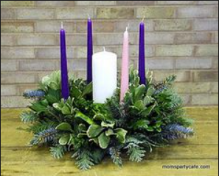
Advent is just around the corner. We will again be hosting an Advent Luncheon on Wednesday, December 13, at 12 p.m. in Fellowship Lounge.

Poinsettias

Again this year, poinsettias will adorn our worship space on Christmas Eve. If you would like to provide one or more, forms will be available on the guestbook stand in Wesley Lounge and in the church
office. The plants are yours to keep following the
service. If you have any questions, please feel free to call the office. Cost is $10.00 per plant and the available colors are red, white, and
pink. The deadline for ordering is
Sunday, December 3.

Leadership
Lay Leader | Lois Fennimore  glfennimore@yahoo.com
Church Council Chair | Mark Robison  majerobi@gmail.com
Treasurer | Sally Ammerman  sallya@wowway.com
Trustees Chair (Building & Property) | Gary Harrison  gwh2510@att.net
Staff-Parish  Co-Chairs (Personnel) | Barbara Lange  langehome.2@gmail.com
Finance Committee | Rick Lange  langehome.1@gmail.com
Pastor | Leslee Fritz  pastorleslee1@gmail.com
Choir Director | Drew Dunham
Music Director /Pianist | Jan Fourn
Administrative Secretary | Cindi Klingel  albionfumc@gmail.com
Housekeeper | Lynn Markovich
Custodian | Larry Maynard
Prayers
Ken Bentley @ Ann Arbor
Hilda Ebbinghaus and Rev. Wyma @ home
Allison Roesti @ Cornerstone, Coldwater
Betty Beese @ Glazier Assisted Living, Chelsea

All Saints 2017
We remember the following:

Florence Sweet Reed May 13, 1918 — January 27, 2017
Nancy Jean Held October 27, 1932 — February 4, 2017
Ruth Ellen Seelye October 26, 1945 — February 5, 2017
Daniel Ralph Seelye February 7, 1940 — September 16, 2017
William Gillham 1933 — October 14, 2017

First United Methodist Church Albion
2017 Annual Charge Conference
Oct. 29. 2017 - Minutes
FUMC Albion Annual Charge Conference was opened by District Superintendent Dale Miller at 11:18 AM, following Sunday Service. Dale Miller introduced himself with both professional and personal information. Opening prayer was given.
Barbara Lange was nominated by Andy French to act as recording secretary. Approved by unanimous vote.
Election of Church Leaders:
Pastor Leslee Fritz announced the consolidation of Endowment Committee into the Finance Committee. A correction was suggested to delete the Co-chair designation for SPRC. Announcement was made a vacancy on Trustees Committee will need to be filled. Motion to approve election of leaders was made. Approved by unanimous vote.
Mark Robison, Chair of Church Council, moved to accept the Pastoral Compensation as proposed for 2018. Approved by unanimous vote.
Mark Robison moved to accept the Household Furnishings allowance of $4,000 as proposed. Discussion regarding Line #14 and #15 itemizing Health Insurance costs ensued. Pastor Leslee explained that 2018 costs have not yet been determined by the Conference. Household Furnishings Allowance was approved as proposed by unanimous vote.
Barbara Lange moved to continue endorsement of Lois Fennimore as a Certified Lay Servant, Certified Lay Minister, and Lay Speaker. Seconded and approved by unanimous vote.
Membership Report:
Pastor Leslee explained that membership data has not been kept current for several years. Updates on church records have begun and will continue as needed for information on inactive members by fall of 2018. Concerns about the process of de-enrolling inactive individuals ensued. Dale Miller reassured that de-enrolling is a 2-year process and clarified there are no per-capita ramifications for carrying or purging inactive members.
District Superintendent Questions:7
Open discussion surrounding three questions ensued: (1) How have we experienced God’s grace in church? (2) How have we extended God’s grace beyond church? And, (3) How do we offer God’s grace to the pastor?
Dale Miller advised that boundary lines, names and leadership for consolidation of districts will be finalized in mid-November 2017. He projected FUMC Albion to be at the western border of District 8. All new districts will encompass a larger geographic area, with greater supervisory load for District Superintendents.
Dale announced a plan to celebrate the change from old district organization to new on or about Feb. 10, 2018. Details will be announced.
Dale Miller announced an initiative to establish a Volunteers in Ministry (VIM) scholarship fund in the name of the Albion District as a legacy. He proposed that the churches of the Albion District together raise $10,000 that would be matched by the District.
Dale Miller concluded by sharing stories of many small churches in the Albion District which are accomplishing big missions.
Charge Conference Minutes (continued)
2017 Charge Conference concluded at 12:30 PM by motion from Bill Rafaill.
Respectfully submitted,
Barbara Lange

UMW had their annual Brunch and Remembrance breakfast on October 28, in Fellowship Lounge. We honored those members who had passed away in the past year; Florence Reed, Nancy Held, Ruth Seelye and Kay (Kemler) Stenman. Several of the deceased’s family members were in attendance. Speaking on behalf of Florence Reed was Donna Gaskell, Nancy Roush honored Nancy Held, LaVada Weeks wrote some memories of her friend Ruth Seelye, and Reverend Leslee spoke of Kay Stenman, who grew up in the Albion FUMC. Many thanks to Donna Williams for providing the music, and Barb Stowell, Polly Moore, Drew Dunham, Rick Lange and Bruce Nelson for providing the food.
UMW News
Looking forward, UMW will again be making Peanut Brittle for our annual sale. Dates will depend on availability of the kitchen and people to help. On November 16, at 1:00 p.m., we will have a Combined Circle Meeting in Wesley Lounge. Jackie Holdsworth will be giving a book review of Braiding Sweetgrass. Then, on December 7, at 7:00 p.m., we will have our annual Ingathering event in Wesley Chapel and Lounge. Our last meeting for this year will be Gwen Bagley presenting on Wesley at CMU: Trip to Nicaragua. This will be a Combined Circle Meeting on December 21, at 1:00 p.m., in Wesley Lounge. Come join us!
Blessings always,
Amy Plassman

Time Change November 5!
Fall back an hour, preferably the night before Sunday, November 5. Those who arrive an hour early will be recruited to the choir!
Community Health Fair

The Albion Health Care Alliance. We are sponsoring a community health fair that will be held on Saturday, November 4, 2017 at the Ludington Center in Albion. Participants of the health fair will enjoy free blood pressure checks, CPR Demos, immunizations, and opportunities for Healthcare enrollments and much more.


Gourmet Nuts and Peanut Brittle
Nuts are now available in both Wesley Lounge and the church office. The cost is $20.00 for a 36 oz. can.

The aroma of Peanut Brittle will soon be filling our building again! What a delicious scent…and taste! The cost will be $6.00 per container and it is will be available in mid-November.

